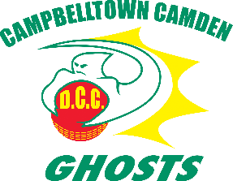
Campbelltown Camden District Cricket Club
C E L E B R A T I N G 3 8 S E A S O N S
“Feel the Spirit”
AW Green Shield Trials

Saturday 2nd April, 2022
Saturday 9th April, 2022
9.00am – 12.00pm
Raby Sports Complex, Raby Rd, Raby

The Campbelltown Camden District Cricket Club is a community-based sporting organisation committed to the development and promotion of cricket at the elite level within the Region of Macarthur and our neighbouring regional areas.

We intend to foster ongoing respect and success by providing a positive and enjoyable cricket experience for all, while developing players, people and partnerships in the community.

Campbelltown Camden DCC players enjoy one of Sydney’s best cricketing facilities – The Raby Sports Complex.

The CCDCC invites all players wishing to trial for the 2022/23 A.W. Green Shield team to attend the Raby Complex on the above date to begin the selection process.

Players must have their own playing and protective gear plus a drink bottle.

The A.W. Green Shield Competition is the Premier Competition for Boy’s under the age of 16 years.

All candidates are asked to complete the trial registration below:

https://docs.google.com/forms/d/e/1FAIpQLSci6R0T6o19USF79FrAROSJaqVzFKrJZKAKbvS0HJMtJsuE7A/viewform

Jason Ellsmore
CCDCC Secretary

Campbelltown Camden District Cricket Club
Secretary: Jason Ellsmore Mobile: 0405 469 636
126 Longhurst Road, Minto 2566 ABN 57 098 941 095
Email: secretary@ghostscricket.com Website: www.ghostscricket.com

